Chingu Voyage nn - Toucans Team #3

Meeting - App Feature Planning

horizontal line

nn March2023 / 05:00 PM GMT +9 (Seoul) 02:30 PM GMT +5:30 (New Delhi)

# ATTENDEES

* @ilanza
* @BreeMudi
* @AndreM
* @Yara⭑
* @Alex Shef
* @zien Al-haoushe

# AGENDA

* Review App Ideas spreadsheet one last time & agree on app to create during this Voyage
* Define Vision Statement
* What are the high-level features in the app?

| **Priority**  **(Must have/Should have/Nice to have)** | **Feature Description**  **(only user-facing features)** | **Issue #** |
| --- | --- | --- |
| Must | Add edit and delete tasks |  |
| Must | Display daily tasks |  |
| Must | (Visual) cue task completion |  |
| Must | Categorisation |  |
| Should | Scheduling: start + deadline |  |
| Should | Task status display (more than 2 options) |  |
| Should | Prioritization |  |
| Should | Sorting/filtering |  |
| Should | Description |  |
| Should | Add and delete task-management (refresh) |  |
| Should | Navigation- change timeline visualization |  |
| Could | Support, feedback, contact |  |
| Could | Notification |  |
| Could | Integration |  |
| Could | Undo |  |
| Could | Recurrent tasks |  |
| Won’t | subtasks |  |

# Audience and Vision:

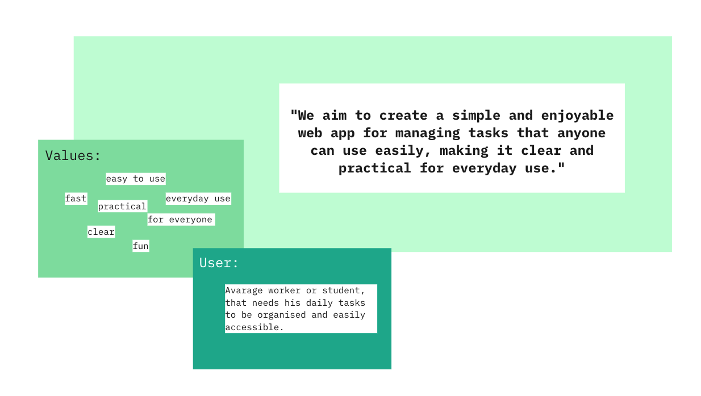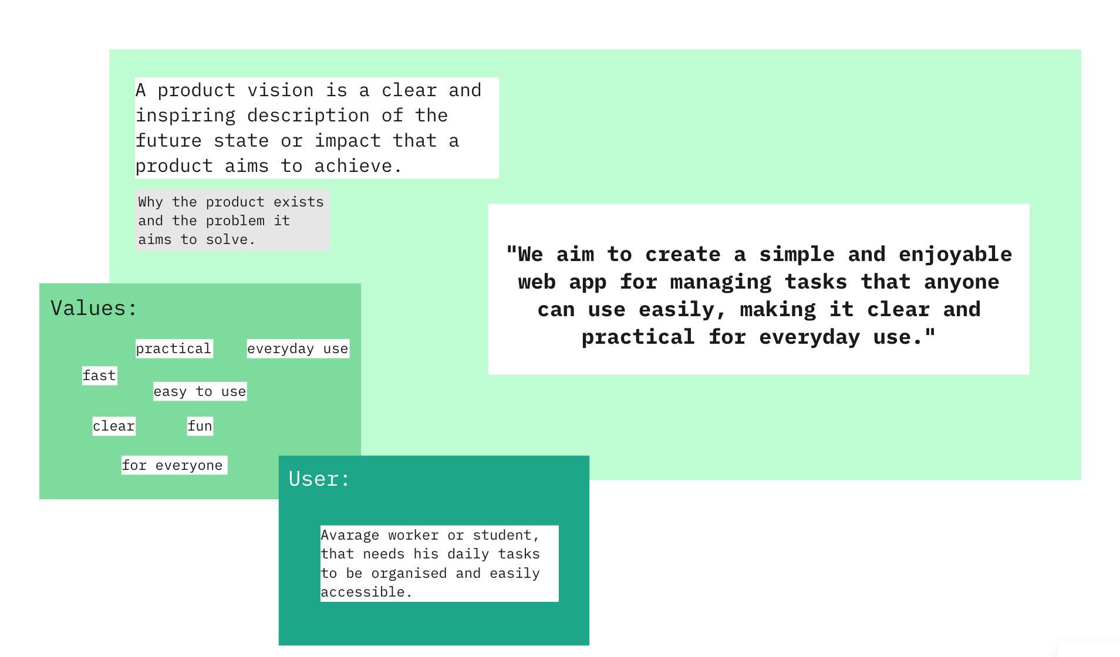

# NOTES

* FUll notes and brainstorming board here: <https://miro.com/app/board/uXjVN6gGsh4=/?share_link_id=565339955632>